Customer Service – Activities

Chapter Four: Nonverbal Communication Skills

Work it Out

Ask a number of your friends (or customers with whom you have good rapport) if there are nonverbal cues and personal habits that you use and have that stand out in their mind or even irritate them in order to get a better understanding of nonverbal cues and personal habits that you might be using excessively or inappropriately. Based on your response, make necessary modifications in your nonverbal communication behavior and eliminate those habits.

Take a few minutes to look at each of the faces shown below. Write the emotion that you believe each image portrays and then compare your response to those of others. Did each person have the same reaction to each nonverbal cue?

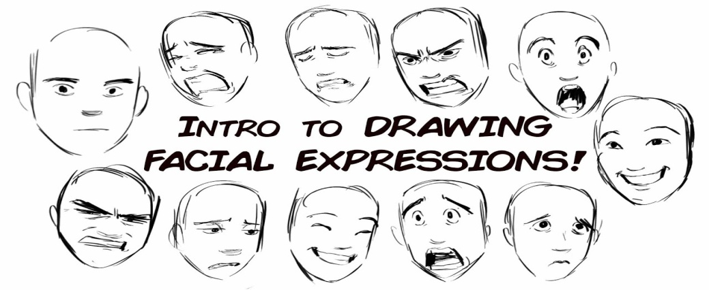

Gesture Practice: To see what you look like when you gesture and communicate nonverbally, stand in front of a mirror or video yourself as you practice expressing nonverbal cues that demonstrate the following emotions:

- Sadness – Frustration – Disgust – Happiness – Love – Fear – Anger – Excitement – Boredom

Once in class, pair up with another student and each of you select an emotion from the list. Take turns and demonstrate each emotion without telling the other person the intended message. After each attempt, discuss how your partner interpreted the emotion and what message you were actually trying to send. If the two differed, discuss why that might be the case and the potential impact on customer service.

Adding Emphasis to Words: To practice how changes in your vocal quality affect the meaning of your message, try this activity.

Pair up with someone. Take turns verbally delivering the following sentences one at a time.

- I said I’d do it.
- I said I’d do it.
- I said I’d do it.
- I said I’d do it.
- I said I’d do it.

Each time, place the vocal emphasis on the word in boldface type. Following the delivery of each sentence, stop and discuss how you perceived the meaning based on your partner’s enunciation and intonation of the key word in the sentence. Also, discuss the impact that you believe such emphasis could have on a customer interaction.

Spatial Perceptions: Pair up with someone and stand facing him or her from across the room.

Start a conversation about any topic (i.e. how you feel about the concepts addressed in this chapter or how you feel about the activity in which you are participating) and slowly begin to move toward one another. As you do so, think about your feelings related to the distance at which you are communicating. Keep moving until you are approximately one inch from your partner. At that point, start slowly backing away – again thinking about your feelings. When you get back to your side of the room, have a seat and answer these questions:

- How did you feel when you were communicating from the opposite side of the room (what where your thoughts)?
- At what distance (moving forward or back) did you feel most comfortable? Why?
- Did you feel uncomfortable at any point? Why or why not?
- How can you use the information learned from this activity in the service environment?

Collaborative Learning Activities

Focus on Your Speech Patterns. Set up a recording device. Then pair up with someone to discuss what you believe are the benefits of understanding and using nonverbal cues for building customer relations (spend at lease five minutes presenting your ideas). Your partner should then present his or her views to you. Once both of you have presented your ideas, listen to the recording with your partner and focus on your speech patterns.

- Are you using appropriate verbal cues in your relationship with others? In what ways?
- Do you use silence effectively? If so, how?
- How did you sound in regard to the following four speech components?
  - Rate – Pitch – Volume – Articulation
- Once you have identified positive and negative areas in your communication, set up an action plan for improvement by targeting the following:
  - Area(s) for improvement
  - Target improvement date
  - Resources needed to improve (assistance of others, training, training materials)
  - Support person(s) – who will coach or encourage you toward improvement

Planning to Serve

Based on the content of this chapter, create a personal action plan focused on improving your nonverbal service to customers. Begin by taking an objective assessment of your current nonverbal skill strengths and areas for improvement. Once you have identified deficit areas, set goals for improvement.

Start your assessment by listing as many strengths and areas for improvement as you are aware of. Share your list with other people who know you well to see if they agree or can add additonal items. Keep in mind that you will likely be more critical of yourself than other people will. Additonally, you may be sending nonverbal signals of which you are not aware. For those reasons, keep an open mind when considering their comments.

Once you have a list, choose two or three items that you think need the most work and can add the most value when interacting with others. List these items on a sheet of paper along with specific courses of action you will take for improvement, the name of someone you will enlist to provide feedback on your behavior, and a specific date by which you want to see improvement. Related to the last, keep in mind that it takes on average 21 to 30 days to see behavioral change; therefore, set a date that is at least in this range.

